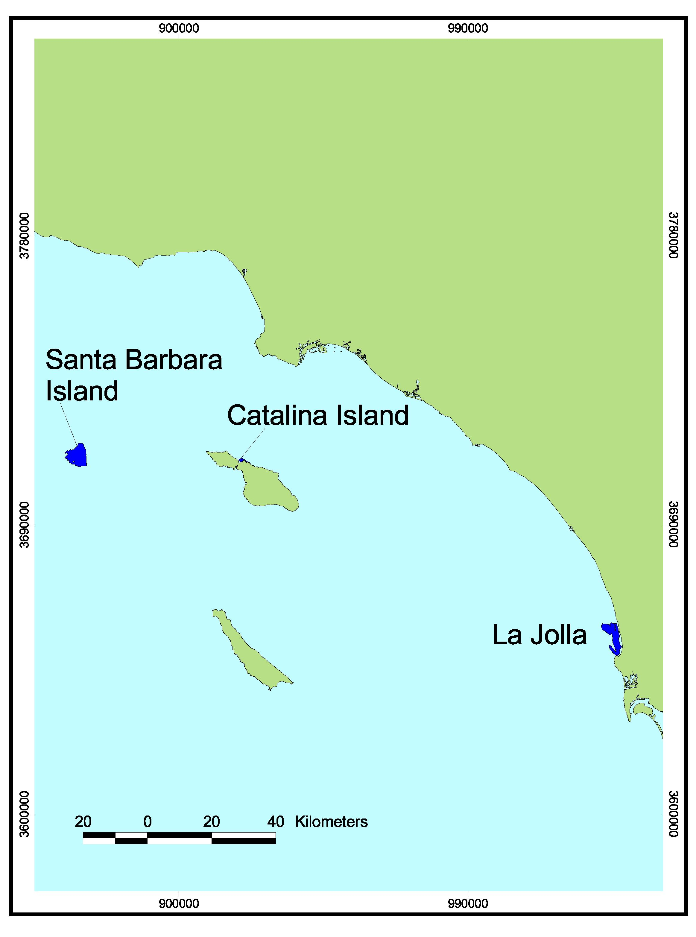
Footprint Map for Southern Region A. All regions included in this volume were surveyed by CSUMB using multibeam imagery (blue) and mapped by the Center for Habitat Studies.

